Dating Preferences in Graduate Students

Natasha Polishchuk, MAT 443 Final Project

Table of Contents

ABSTRACT 1

BACKGROUND 1

PURPOSE 2

SAMPLE COLLECTION 2

VARIABLES 2

SAMPLE DESCRIPTIVES 4

RESULTS 7

VALIDATION 15

CONCLUSIONS AND RECOMMENDATIONS 17

LIMITATIONS 17

REFERENCES 18

APPENDIX 19

## ABSTRACT

Because the rate of women graduating college has risen from five women to every four men in the mid-1990s to four women for every three men, and women prefer college-educated men, this group of men are in higher demand. Therefore, women are pushed to be more attractive to compete. The purpose of this study is to evaluate whether this appraisal is true, and which other attributes each sex looks for in a mate. Four speed dating events executed at Columbia University were compared using MDPREF mapping technique in SAS v. 9.3.

The more desirable majority of men preferred a small group of the most attractive women. A minority of men selected average or above average looking women who were rated Fun and liked sports. Less attractive women were rated lower and not liked. Half of women chose the top most attractive, racially similar, and highest self-assessing men. A minority of women chose average or above average looking men who were smart and ambitious. Men rated less attractive but smart or ambitious still had a few admirers in every wave.

Therefore, the selection is not as stark as Jon Birger proposes in his interview, but there are some definite patterns in date selection. Men are more focused on looks than women, and women find ambition to be more important. Coming from a wealthier zip code can promote advantage in dating, though the connection is unclear. Career plans do not seem to be important, though age and confidence may be for women.

## BACKGROUND

In an interview with the podcast *Art of Manliness,* author Jon Birger uses animal research to support a hypothesis that male to female ratios in an environment alter dating and sexuality norms (Date-onomics — How Skewed Sex Ratios on College Campuses Are Affecting Courtship and Marriage, 2016). Because the rate of women graduating college has risen from five women to every four men in the mid-1990s to four women for every three men, and women prefer college-educated men, this group of men are in higher demand. He credits this difference in college education to childhood development, indicating that teenage boys are behind girls in high school. Greater emphasis has been placed on high school grades and performance, so teenage girls are going to college at a higher rate. He Conger agrees that the emphasis on high school GPA is responsible for the gender gap in college enrollment, and sees this trend continuing to rise in the future (High school grades, admissions policies, and the gender gap in college enrollment, 2015). In graduate school, the gender gap is even higher at over 60%, and men are generally less motivated to complete schooling, especially in female-dominated fields, in which they are more likely to feel excluded (Isacco & Morse, 2015). Possibly, women could find motivation, and the related attribute ambition, to be desirable in a partner if they place value on having completed a degree.

Birger cites his own interviews with women, in which he finds that women are frustrated by a detached attitude from male dates (2016). He also notes that even in conservative religious groups like Mormon and Orthodox Jewish communities, women are pushed to be more attractive to compete and the incidence of eating disorders and plastic surgery rises when there is a gender imbalance. New York is on his list of cities that are particularly bad for women dating, whereas West Coast cities like San Francisco or Seattle have more favorable ratios.

As the original researcher conducting this speed dating experiment, Fisman investigated how race or ethnic background affects partner selection on first impression (Racial Preferences in Dating, 2008). He found that men as a whole did not strongly prefer partners of the same race, though women did. Older subjects were less likely to have this preference. This could not be explained by more shared interests or perception that the shared race was more attractive, but the subject’s place of origin did strongly influence this. Specifically, the author used the General Social Survey (GSS) and World Values Survey (WVS) to determine which places were less tolerant, and found that subjects from these regions had similar outlooks. Additionally, subjects who were themselves physically attractive cared were less likely to exhibit this preference.

## PURPOSE

Hypothesis: Because of the skewed sex ratio, women face a competitive environment in the Columbia graduate and professional student dating pool. They place greater emphasis on Ambition and Race and are less selective otherwise, whereas men focus on Attractiveness and are more selective.

Objective: Determine whether this is supported by the data. If so, are there any other attributes that are important to each sex?

## SAMPLE COLLECTION

Subjects attended one of 21 Speed Dating events held at Columbia University between 2002 and 2004, modeled on the script and protocol set by the New York-based company Hurry Date. Graduate and professional students from Columbia University were recruited using email and campus fliers. Each registered via website and completed a pre-event background survey detailing their background, professional plans, and attitudes toward dating.

Each participant kept track of their ratings throughout the evening using a clipboard with a cover, and were promised that results would be held confidential. They rated each date on a 1-10 Likert scale in the following attributes: Attractive, Sincere, Intelligent, Fun, Ambitious, Shared Interests, and how much they liked them overall. For each date, they also circled “yes” or “no” indicating whether they wanted to meet the person again.

The actual environment involved a closed room on campus or at a restaurant, with table arrangement, music, and lighting held constant across sessions. Two sessions were held each evening, and alcohol was not served. The women all sat on one side of the table, and men all on the other. Each partner spoke to the other for four minutes. The participants had one minute to complete their score cards, and then the partners rotated again. The next day, everyone was sent an email to complete a follow-up survey, after which they received an email of match results.

Because each person was judged by each other on multiple criteria, there were more variables than observations in each set. However, this is acceptable in the MDPREF analysis used for analysis (The PRINQUAL Procedure).

## VARIABLES

|  |  |  |  |
| --- | --- | --- | --- |
| Wave # | Date | # Males | # Females |
| 6 | March 26th ‘03 | 5 | 5 |
| 7 | March 26th ‘03 | 16 | 16 |
| 8 | April 2nd ‘03 | 10 | 10 |
| 9 | April 2nd ‘03 | 20 | 20 |

Though additional variables were collected, this study selected those that were most complete for the four events considered, and predicted to be most applicable in the analysis of dating preferences. As presented in the “Speed Dating Data Key.doc” available on Kaggle, here are the abridged variables:

iid: unique subject number, group(wave id gender)

pid: _ partner’s iid number

age_o: age of partner

race_o: race of partner

age:

field: field of study

race:

Black/African American=1, European/Caucasian-American=2, Latino/Hispanic American=3, Asian/Pacific Islander/Asian-American=4, Native American=5, Other=6

imprace:

How important is it to you (on a scale of 1-10) that a person you date be of the same racial/ethnic background?

imprelig:

 How important is it to you (on a scale of 1-10) that a person you date be of the same religious background?

 from:

Where are you from originally (before coming to Columbia)?

zipcode:

What was the zip code of the area where you grew up?

income:

Median household income based on zipcode using the Census Bureau website:

<http://venus.census.gov/cdrom/lookup/CMD=LIST/DB=C90STF3B/LEV=ZIP>

When there is no income it means that they are either from abroad or did not enter their zip code.

date:

In general, how frequently do you go on dates?

Several times a week=1, Twice a week=2, Once a week=3, Twice a month=4, Once a month=5, Several times a year=6, Almost never=7

go out:

How often do you go out (not necessarily on dates)?

Several times a week=1, Twice a week=2, Once a week=3, Twice a month=4, Once a month=5, Several times a year=6, Almost never=7

career:

What is your intended career?

How interested are you in the following activities, on a scale of 1-10?

sports: Playing sports/ athletics, tvsports: Watching sports, excercise: Body building/exercising, dining: Dining out, museums: Museums/galleries, art: Art, hiking:  Hiking/camping, gaming: Gaming, clubbing: Dancing/clubbing, reading: Reading, tv: Watching TV, theater: Theater, movies: Movies, concerts: Going to concerts, music: Music, shopping: Shopping, yoga: Yoga/meditation

exphappy:

Overall, on a scale of 1-10, how happy do you expect to be with the people you meet

during the speed-dating event?

We want to know what you look for in the opposite sex.

You have 100 points to distribute among the following attributes -- give more points to those attributes that are more important in a potential date, and fewer points to those attributes that are less important in a potential date.  Total points must equal 100. (*Note: Although the authors state that Waves 6-9 used a 1-10 scale for this question, the source data had values distributed based on 100 point value as instructed here. This discrepancy is puzzling, but no other Waves appear to have used a 1-10 scale, so the data does not appear to have been corrupted. This question was asked multiple times, but only the pre-event response was used here.)*

attr1_1  Attractive, sinc1_1 Sincere, intel1_1 Intelligent, fun1_1 Fun, amb1_1 Ambitious, shar1_1 Has shared interests/hobbies

How do you think you measure up?

Please rate your opinion of your own attributes, on a scale of 1-10 (be honest!):

attr3_1 Attractive, sinc3_1 Sincere, int3_1 Intelligent, fun3_1 Fun, amb3_1 Ambitious

Overall, how much do you like this person?

(1=don't like at all, 10=like a lot) like

## SAMPLE DESCRIPTIVES

Fifty-one members of each sex participated in the four waves, with an equal number of men and women at each event (5 pairs in Wave 6, 16 pairs in Wave 7, 10 pairs in Wave 8, and 20 pairs in Wave 9). One woman did not complete the pre-event background survey.

The participants were asked where they were from, with 24% of women and 31% of men identifying as foreigners. However, their competence with the English language and length of time spent in the United States was not assessed, though these may affect the person’s ability to communicate with their dates.

The participants also reported their current field of study and future career plans. The three most popular fields for both sexes were Business/Economics/Finance, Life Sciences, and Political Science. Banking/Finance and Academic/Research are the most popular career plans for both sexes. Men and women in this sample have similar mindsets on educational and professional aspirations. These responses did not appear to directly predict date preferences.

In a survey completed before the event, men and women answered questions about themselves and their expectations. These are summarized in Table 1. The participants were approximately the same age, with women averaging 26.36 years old (standard deviation 3.32) and men 27.08 (3.76). Women found shared race or ethnic background and shared religion to be more important by greater than 1 point. Both groups seemed to go on dates with approximately the same frequency (5 = “Once a month”), and go out at the same rates (2 = “Twice a week”). Each had approximately the same expectation that they would be happy with the people they met, which was fairly neutral at 5.20 (standard deviation 1.41) for females and 5.51 (standard deviation 1.72) for males.

Additional questions were asked about each person’s interests. Men and women had rated sports, TV sports, exercise, dining, museums, art, hiking, gaming, clubbing, reading, theater, movies, concerts, and music similarly. Women gave TV, shopping and yoga ratings that were at least one point higher than men.

Table 1. Self-reported responses before the event. Age = age in years, imprace = importance that a date be of the same racial/ethnic background (1-10 scale), imprelig = importance that date be of the same religious background (1-10 scale), date = frequency of dates (1-7 scale), go_out = frequency of social outings which are not necessarily dates (1-7 scale), exphappy = how happy do you expect to be with the people you meet at this event (1-10 scale).

|  |  |  |  |  |  |  |  |
| --- | --- | --- | --- | --- | --- | --- | --- |
| **Survey Responses** | | | | | | | |
| **Females** |  | age | imprace | imprelig | date | go_out | exphappy |
| *Average* | 26.36 | 5.14 | 4.10 | 4.94 | 2.12 | 5.20 |
| *Std Dev* | 3.32 | 3.12 | 2.84 | 1.45 | 1.02 | 1.41 |
| *Skew* | 0.87 | 0.02 | 0.63 | -0.48 | 0.82 | -0.28 |
|  |  |  |  |  |  |  |  |
| **Males** |  | age | imprace | imprelig | date | go_out | exphappy |
| *Average* | 27.08 | 3.76 | 3.14 | 5.12 | 2.25 | 5.51 |
| *Std Dev* | 3.76 | 2.70 | 2.55 | 1.31 | 0.77 | 1.72 |
| *Skew* | 1.57 | 0.53 | 0.87 | -0.23 | 0.34 | 0.13 |

Each participant was asked to distribute 100 points over six qualities, with more points to those they thought were more important. As Table 1 shows, women found Attractiveness to be less important than men by a full standard deviation. Instead, women valued Ambition by an average of three more points. Both sexes placed the lowest emphasis on shared interests, and each found Sincerity and Fun to be approximately equally important. The highest weight was placed on Intelligence by both sexes.

Table 2. Preferred attributes by sex. Each participant was given 100 points to distribute over the 6 key factors (Attr = Attractive, Sinc = Sincere, Intel = Intelligent, Fun = Fun, Amb = Ambitious, Shar = Has shared interests/hobbies). Fractional points were allowed.

|  |  |  |  |  |  |  |  |
| --- | --- | --- | --- | --- | --- | --- | --- |
|  |  | **Prefered attributes in a date** | | | | | |
| **Females** |  | Attr | Sinc | Intel | Fun | Amb | Shar |
| *Average* | 14.75 | 18.28 | 18.45 | 17.53 | 16.35 | 14.65 |
| *Std Dev* | 2.93 | 2.24 | 1.52 | 1.92 | 2.66 | 2.61 |
| *Skew* | -0.64 | 0.20 | 0.50 | -0.26 | -0.82 | -0.65 |
|  |  |  |  |  |  |  |  |
| **Males** |  | Attr | Sinc | Intel | Fun | Amb | Shar |
| *Average* | 17.59 | 17.67 | 19.29 | 18.21 | 13.14 | 14.09 |
| *Std Dev* | 3.55 | 3.15 | 2.31 | 2.71 | 4.69 | 4.85 |
| *Skew* | -0.04 | -1.44 | 0.13 | 0.84 | -0.87 | -0.60 |

In Table 2 , the ratings on these five key attributes (Attractive, Sincere, Intelligent, Fun, and Ambitious) are averaged by sex of participant. In the top section, the participants were rated by their dates on these and the extra variable of Shared Interests. Men rated women slightly more favorably in the Attractiveness variable, while women rated men more favorably in the Ambition variable. The highest ratings by all participants were for Intelligence, and lowest for Shared Interests.

The bottom part of this table shows how participants rated themselves. On average, women found themselves to be more attractive than men by almost a full point (8.02, standard deviation of 0.96) whereas men rated themselves lowest on attractiveness (7.06, standard deviation of 1.36). Men also rated themselves more than a point less than women on Intelligence, and slightly lower on Ambition.

As a whole, women saw themselves in a more favorable light, and rated themselves more highly in all categories than their dates. Men were perceived as significantly less Attractive, Sincere, and Fun than their self-perceptions. However, men were rated higher on Intelligence and Ambition than their own estimates. In fact, men received slightly better ratings on these two variables than they gave women.

Table 3. Comparison of their dates’ assessments with self-assessments by sex for Waves 6-9. Attr = Attractive, Sinc = Sincere, Intel = Intelligent, Fun = Fun, Amb = Ambitious, Shar = Has shared interests/hobbies. All rated on a scale of 1-10.

|  |  |  |  |  |  |  |  |
| --- | --- | --- | --- | --- | --- | --- | --- |
|  |  | **Ratings by the opposite sex** | | | | | |
| **Females** |  | Attr | Sinc | Intel | Fun | Amb | Shar |
| *Average* | 6.53 | 7.34 | 7.40 | 6.51 | 6.71 | 5.58 |
| *Std Dev* | 1.05 | 0.61 | 0.55 | 0.87 | 0.63 | 0.75 |
| *Skew* | -0.27 | -0.18 | 0.20 | -0.20 | -0.18 | -0.45 |
|  |  |  |  |  |  |  |  |
| **Males** |  | Attr | Sinc | Intel | Fun | Amb | Shar |
| *Average* | 6.09 | 7.32 | 7.64 | 6.62 | 7.28 | 5.91 |
| *Std Dev* | 1.21 | 0.58 | 0.62 | 1.03 | 0.69 | 0.85 |
| *Skew* | -0.10 | -0.70 | -0.33 | -0.29 | -0.10 | -0.19 |
|  |  | **Self-Ratings** | | | | |  |
| **Females** |  | Attr | Sinc | Intel | Fun | Amb |  |
| *Average* | 8.02 | 8.64 | 8.42 | 8.90 | 8.22 |  |
| *Std Dev* | 0.96 | 1.19 | 1.09 | 0.86 | 1.33 |  |
| *Skew* | -0.33 | -0.99 | -0.33 | -0.20 | -0.53 |  |
|  |  |  |  |  |  |  |  |
| **Males** |  | Attr | Sinc | Intel | Fun | Amb |  |
| *Average* | 7.06 | 8.24 | 7.39 | 8.53 | 7.47 |  |
| *Std Dev* | 1.36 | 1.38 | 1.59 | 1.19 | 1.96 |  |
| *Skew* | -0.01 | -0.49 | -0.56 | -0.85 | -0.61 |  |

To determine whether the speed daters were accurately predicting their own desirability, a separate correlation matrix was determined for each sex. As a nonparametric measure of the association of rank values, the Spearman correlation coefficient was used (Example 2.1 Computing Four Measures of Association). First, the ratings were compared for women in Table 4. The one woman who did not complete a self-assessment before the event was excluded from calculations. Slight correlations can be seen for a self-rating of Fun linking to increased attractiveness ratings by others (Spearman correlation coefficient 0.29, p = 0.04). A self-rating for Ambitious also has a slight correlation with others’ ratings of Attractiveness (0.30, p = 0.04) and Fun (0.37, p = 0.01). However, a conservative statistician may choose to reject such slight correlations. As a whole, Table 4 indicates that women’s self-assessments did not correlate with their dates’ responses. This confirms the findings in Table 3 that women were, as a group, overconfident.

Table 4. Spearman correlation coefficients for the 50 women who rated themselves on the 5 categories (Attr = Attractive, Sinc = Sincere, Intel = Intelligent, Fun = Fun, Amb = Ambitious, Shar = Has shared interests/hobbies. All rated on a scale of 1-10.), and their partners' average responses. The prefix “Self-“ refers to a woman’s rating of herself, while the prefix “Avg-“ refers to average ratings by all date partners during the event.

|  |  |  |  |  |  |  |
| --- | --- | --- | --- | --- | --- | --- |
| **Spearman Correlation Coefficients Prob > |r| under H0: Rho=0** | | | | | | |
|  | **AvgAttr** | **AvgSinc** | **AvgIntel** | **AvgFun** | **AvgAmb** |
| **SelfAttr** | 0.05875 0.6853 | -0.01061 0.9417 | -0.16258 0.2593 | 0.12315 0.3942 | -0.10638 0.4622 |
| **SelfSinc** | 0.09972 0.4908 | 0.10777 0.4563 | 0.10239 0.4792 | 0.05639 0.6973 | 0.17693 0.2190 |
| **SelfFun** | 0.28923 0.0416 | -0.01138 0.9375 | -0.12046 0.4047 | 0.15732 0.2752 | 0.04939 0.7334 |
| **SelfIntel** | -0.01600 0.9122 | -0.12865 0.3732 | 0.01580 0.9133 | -0.15673 0.2771 | -0.25443 0.0746 |
| **SelfAmb** | 0.29292 0.0390 | -0.08184 0.5721 | -0.10323 0.4756 | 0.37088 0.0080 | 0.27260 0.0555 |

Table 5 shows the correlations between male self-assessments and their partners’ average ratings. A slight correlation appears between the self-rated Fun and others’ perceptions of Fun (0.36, p = 0.01), and self-rated Ambition and others’ perceptions of Ambition (0.51, p = 0.0001). The other categories show no correlation, so that men as a whole are equally poor at predicting their own desirability as women.

Table 5. Spearman correlation coefficients for the 51 men who rated themselves on the 5 categories (Attr = Attractive, Sinc = Sincere, Intel = Intelligent, Fun = Fun, Amb = Ambitious, Shar = Has shared interests/hobbies. All rated on a scale of 1-10.), and their partners' average responses. The prefix “Self-“ refers to a woman’s rating of herself, while the prefix “Avg-“ refers to average ratings by all date partners during the event.

|  |  |  |  |  |  |
| --- | --- | --- | --- | --- | --- |
| **Spearman Correlation Coefficients, N = 51 Prob > |r| under H0: Rho=0** | | | | | |
|  | **AvgAttr** | **AvgSinc** | **AvgIntel** | **AvgFun** | **AvgAmb** |
| **SelfAttr** | 0.21625 0.1275 | 0.01695 0.9060 | -0.01862 0.8968 | 0.08595 0.5487 | 0.16277 0.2538 |
| **SelfSinc** | -0.06828 0.6340 | 0.13884 0.3312 | 0.13226 0.3549 | -0.05540 0.6994 | 0.04087 0.7758 |
| **SelfFun** | 0.18506 0.1936 | 0.16063 0.2601 | 0.04179 0.7709 | 0.35823 0.0098 | 0.22835 0.1070 |
| **SelfIntel** | 0.01849 0.8975 | -0.01696 0.9060 | 0.15589 0.2747 | -0.07935 0.5799 | 0.15476 0.2782 |
| **SelfAmb** | 0.13814 0.3337 | 0.13633 0.3401 | 0.23112 0.1027 | 0.20029 0.1588 | 0.50715 0.0001 |

## RESULTS

The hypothesis based on the background review is that male graduate students are more selective than female graduate students. Thus, the objective is to determine whether this is true, and identify which qualities each sex seeks in a potential mate.

Multidimensional Preference Analysis (MDPREF) was used to determine dates’ responses to participants based on their responses to the question “Overall, how much do you like this person? (1=don't like at all, 10=like a lot)”. This technique is designed for visualizing opinion-based responses for multiple subjects by multiple judges. In a comparison of seven preference mapping techniques, Yenket, et al suggest that MDPREF gives the highest number of judges who map closest to their favorites (2011). They also note that the researcher must reference back to the original data when interpreting the maps, or the results could be misleading.

At each event, each female was rated by all of the other males in the group, then eigenvalue decomposition was used to convert the males’ preferences into principal component variables (Truxillo, 2015). Finally, a biplot was used to display the judges and females onto a 2-dimensioinal plane. As explained by the SAS Institute, “A biplot displays the judges and objects in a single plot by projecting them onto the plane in the transformed variable space that accounts for the most variance” and offers the advantage of producing coordinates that do not depend on the sample size (The PRINQUAL Procedure). Then, a preference mapping was created to combine vector models for each of the six attributes (Attractive, Sincere, Intelligent, Fun, Ambitious, and Shared Interests) in a space defined by each of the women evaluated. The attribute ratings are averages of all ratings for each woman. Code provided by the SAS Institute was modified to create these two plots and can be viewed in the Appendix A (The TRANSREG Procedure). The same steps were repeated, with women ranking men. Each of the four waves was analyzed separately to look for patterns in dates’ preferences.

As the event with the greatest number of participants, Wave 9 was analyzed first. Twenty women were rated by each of 20 male date partners during the event. As Figure 3 indicates, the scree plot shows that four principal components account should be retained, with a separation between these and the remaining components. Seven of the components are zero because there are seven fewer observations than variables. One of the observations was omitted from this initial plot due to a missing data point.

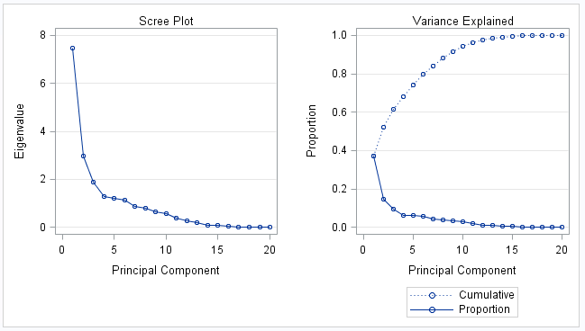

Figure . Initial Eigenvalue plot for ratings of women in Wave 9.

The PROC PRINQUAL was used next to monotonically transform the raw judgements so that two principal components could account for as much variance as possible. By default, this procedure accounts for missing data using variable means as initial estimates (The PRINQUAL Procedure). Because the data consisted of ordinal rankings, the MONOTONE option was selected for a nonmetric MDPREF analysis. A new dataset is created featuring standardized principal component scores and structure matrix. In the iteration history, the proportion of variance accounted for by the first two components is increased from an initial 0.51 to 0.65. However, the Average Change, Maximum Change, and Criterion Change begin to increase on the 23rd iteration, leading to suspicion of a degenerate solution. Therefore, the one missing value is replaced with the mean ranking for judge M229. Figure 4 shows the first and last five iterations, in which the Average Change, Maximum Change, and Criterion Change are continuously decreasing, with the exception of one slight increase on the final iteration of Maximum Change. The algorithm does not converge, however the criterion change is small enough to indicate that more iterations are unlikely to have a significant effect. The variance increase is unchanged, still increasing from 0.51 to 0.65.

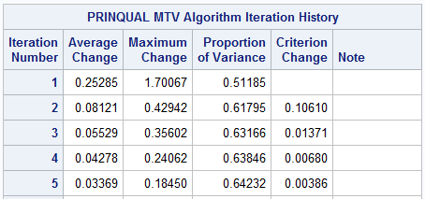

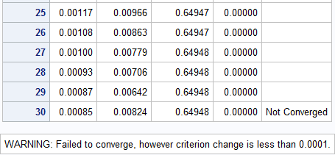

Figure . Abridged Iteration History with Single Missing Value Estimated as Mean.

Next, a biplot is printed of this new data. In Figure 5, thirteen judges point to the right and slightly down (between 3 and 4 ‘o’ clock) in a tight vector grouping, with a few women (200, 212, 195, 208) projecting a short distance down the vectors. This grouping indicates the judges have similar preference patterns, but only moderate interest in these women. These women are all in their mid-20s, American, and rated higher than average on all attributes with the exception that 195 received a lower rating on ambition. They rated themselves higher than average on all attributes, and liked sports. This group is labeled “Confident Athletes”.

The four judges grouped between 1 and 2 ‘o’ clock seem to be somewhat less selective, as six women are clustered within or around these vectors. Five of the six came from New York or New Jersey, and one was from Cameroon. With the exception of subject 199, all said they went out several times a week or twice a week. This group is labeled the “Northeastern Party Girls”.

A few women are isolated on the right side of the map (198, 194, 196) with no admirers. These women received lower than average rankings in all attributes. 194 and 198 received only 4.6 for Attractiveness, a full 2 points less than average (6.5 with a standard deviation 0.99 for the other women at the same event). Only two judges have any strong preferences for the women; M233 for 210, and M224 for 197 and 211. No clear descriptive values appear as to how the women are grouped on the chart, though component 2 may be a weak race variable. Women on the top half are 70% White, 15% Hispanic, with one Asian and one Black woman. Women on the bottom half are 43% White, 29% Black, and one Asian and one Other woman.

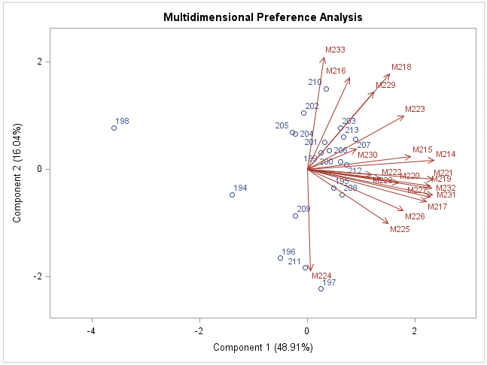

Figure . MDPREF of female rankings in Wave 9.

The second principal analysis is shown in Figure 6. The data still support a four component analysis, but unfortunately this representation is not easily achievable in 2-dimensional space. This indicates that there is an additional dimension that is not accounted for in the MDPREF plot in Figure 5. However, additional analysis of attributes can further explain how the men viewed their dates.

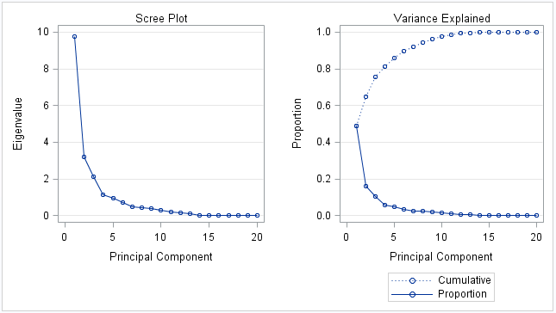

Figure . Second Principal Analysis of Transformed Data.

In preference mapping, the average ratings for each woman of the six attributes (Attractive, Sincere, Intelligent, Fun, Ambitious, and Shared Interests) were mapped as vectors. One point for each woman and six points for each of the six ratings were input to the %PLOTIT macro (see code in Appendix A). Women closer to the top of an attribute rating received more favorable appraisals. Because the vectors are so tightly clustered, it seems men do not make a large distinction between attribute ratings and Dimension 1 captures most of these rankings.

In this case, subject 200 was thought to be intelligent, sincere, and somewhat fun. Subject 212 also appeared sincere and had some shared interests with the men on the dates. These were in the group of women in the thirteen-judge cluster in Figure 5. Subject 198 is the farthest away from all these ideal points, again we see that she was viewed unfavorably. These six attributes did not appear to explain why other judges liked 210 and 211 so much, so this must be based on an unlisted quality or personal preference.

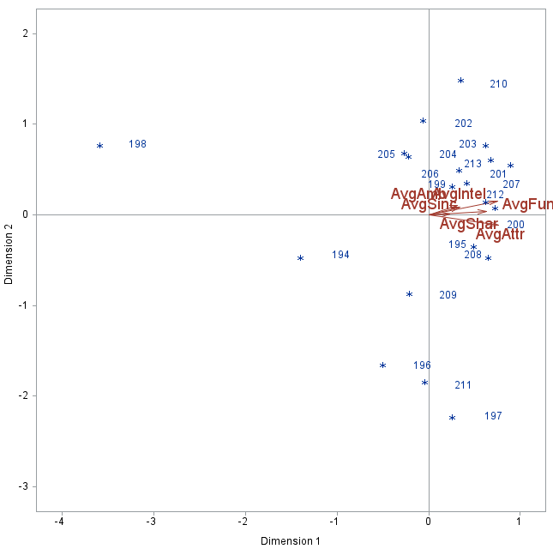

Figure . Preference mapping for women with attribute rankings.

The identical analysis was performed for the rating of men by women in Wave 9, so the detailed steps are omitted, and only the PCA summary, MDPREF chart, and Preference Ratings chart are presented. Eighteen of the twenty rankings for judge 209 were missing, so she was excluded from the chart. One data point for the ranking of subject 233 by judge 200 was missing, and the mean ranking by judge 200 was used in this case.

Again, the principal component analysis indicates that a large number of components (six in this case) would typically be needed to explain a sufficient portion of the variance. The PRINQUAL procedure is used to maximize the variance explained by the first two components, and the proportion of variance increases from 0.47 to 0.59. Though the algorithm does not converge in 30 iterations, the criterion change is sufficiently small to indicate more iterations would be unlikely to affect results. The Average Change, Maximum Change, and Criterion Change do increase slightly in steps 13 through 19, so this may be a cause to suspect a degenerate solution. However, because this only occurs for these few steps, convergence is nearly reached by 30 iterations, and the final data do not supply a perfect fit, we accept these results and proceed. The second principal component analysis shows that three components would better serve the data. Thus, though two components do not capture an ideal amount of variation of the data in this case, they are used in order to simplify comparison between events and sexes.

The resulting MDPREF graph of male rankings in Figure 8 has similar groupings to that of the female rankings in Figure 5. Again, there are a large number of judges (11 in this case) grouped between 3 and 5 ‘o’ clock, with a moderate preference for a handful of subjects (231, 214, 229, 227, 219) and one stronger preference for subject 226 by judge F202. This cluster of men is confident, rating themselves higher than average on self-assessments, particularly in intelligence and ambition. Five out of the six are white, with one Hispanic subject. They are also from large cities in the US, with one exception from Spain, city not provided. Sixty-four percent of the judges in this area are also white, with 18% Asian and 18% Hispanic. Three of the six plan to go into finance or banking after graduation. Race appears to play a small but noticeable role in partner selection. This set is labeled the “Confident Urbanites”.

A smaller group of six judges shows a moderate preference for subjects 223, 233, 225, 217, 215. This cluster is rated less attractive than the previous group, aged in their mid to late 20s, and with no majority of race. Three of these five plan to work in finance or banking. It is unclear whether women clearly prefer men focused on this career, or it is simply a more popular choice among men. This group is called the “Mature Career-seekers”. This group and the “Confident Urbanites” are also the more selective judge cluster who only moderately liked four women.

Another cluster of four men (220, 221, 224, 228) is visible at the top of the chart, where three of the four are from other countries, and all received higher than average intelligence rankings. No judge vectors touch these directly, so it was possible that women admired their intellect but did not personally connect with the men. This set is labeled the “Solid Brains”.

Judges F205 and F197 face off into their own separate direction, with the latter showing a strong preference for subject 216. A couple men are not favored at all (222, 230). Subject 230 was the oldest at 42 years old. Although 232 was not well rated by most of the women and is distant from the other vectors, judge F197 rated him a 10 on the “Like” scale, so it is possible he is a divisive figure. Similarly, judge F205 gave 222 a 10 ranking, though most responded unfavorably to him. He received the lowest average rating on Attractiveness (3.2 as compared to an average of 5.97 with a standard deviation of 1.29 for men in Wave 9), but higher than average men in his group on Intelligence (8.2 as compared to 7.86 with a standard deviation of 0.56).

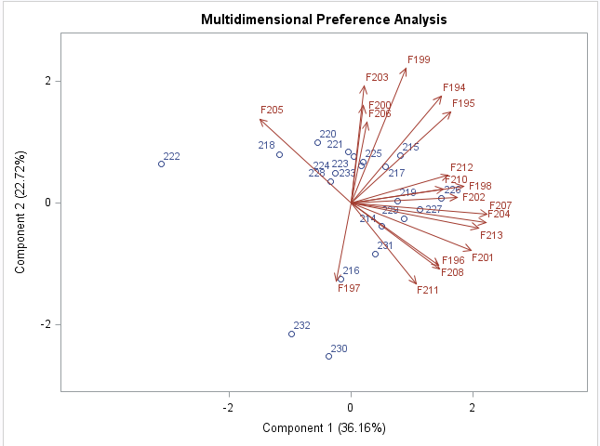

Figure . Rankings of male subjects by female judges in Wave 9.

Figure 9 shows a broader distribution of vectors than for the earlier Preference Mapping in Figure 7. Rather than being clustered in a narrow thirty degree slice, the attributes are now distributed throughout the upper right quadrant. Intelligence and Sincerity point directly in the positive direction on Dimension 2, and Fun points directly in the positive direction in Dimension 1. The group we labeled “Confident Urbanites” is higher on the Shared Interests, Attractiveness, and Fun attributes, but is not favorably seen in the Intelligence and Sincerity categories. The “Mature Career-seekers” are higher on the Intelligence and Sincerity attributes, and still on the positive side of all other attributes. The final group, the “Solid Brains”, are also high on these two attributes, but thought to be less Fun, and is on the more negative side of Shared Interests and Attractiveness.

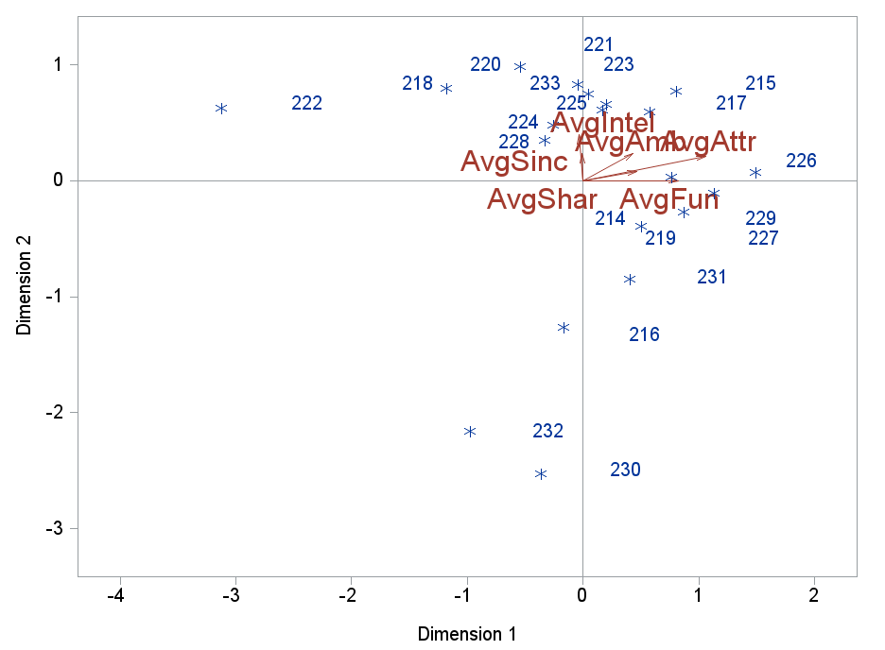

Figure . Preference Ratings for Male Subjects by Female Judges.

Thus, we can draw some limited conclusions on the dating preferences of male and female graduate students from this analysis. The majority of men (65%) favored a limited group of women (20%) who were confident and shared their interest in sports, while a minority of men (20%) were less limiting in their selection and liked the group of five women (25%) who were from the region around Columbia University and were socially active. Attractiveness heavily influenced selection, though the effect of race is murky. Men were narrower in their rankings, probably ranking women similarly in all attributes if they liked them as a whole.

Women were less uniform in their selection, and the majority (58%) favored a larger group of men (30%) who were confident, were rated Fun by others, and mostly came from urban areas. This group of judges and subjects was largely white, so race also played a role in the selection. A clustered minority of women (32%) liked a cluster of men (25%) who were not distinguished by race, but by their higher ratings in Intelligent, Sincere, and Ambitious while still being on the right side of the Attractiveness vector. Men who were rated high in Intelligence and Sincerity but lower in Attractiveness were not well-liked by most women. The one man older than average (42 years old) was liked by one judge but not the rest.

Both sexes admire people who are good-looking. A slight preference is seen for those from wealthier areas. Some men also want women who share their interest in sports or go out frequently. Men in the desirable groups are more selective. Women are too, but fewer are placed in this top tier of desirability. Some women place greater emphasis on men being smart and driven rather than their hobbies, but few would select a smart man who was not close in decent-looking. Age and confidence levels may be influences, and strong preference for same race is visible.

## VALIDATION

With such a small sample size, any researcher would be hesitant to extrapolate the conclusions to graduate students, even for the limited population of Columbia University. However, introducing more dates to judge each other would increase fatigue or alter results as subjects gained experience in the 4-minute conversation format. Therefore, the MDPREF charts were compared to the other three events conducted that same week, but with different participants. Wave 6 was conducted on March 26th, 2003 with five members of each sex, Wave 7 was conducted the same day with 16 of each, and Wave 8 was conducted on April 2nd, 2003 (the same day as Wave 9 above) with 10 of each. The charts were constructed with the same steps as previously explained, so only the results are shown here.

In the small sample set of Wave 6, the male judges show no clear preference for any of the women. Four of the five participants were rated below the average of 6.53 (standard deviation 1.05) for Attractiveness, though higher than average for Sincerity, Intelligence, Fun, and Ambition. The female judges are more favorable, with F133 responding to subject 137, who shared her race, but differed on how frequently he went out, rated himself higher than she did, and was from a wealthy zip code in New York whereas she was from an unspecified city in China. F136 liked subject 138. She did not complete a pre-event survey, so her characteristics are unknown, but subject 138 can be characterized as highly rated on all attributes, aged 32, White, from the wealthy suburb of Greenwich, CT, seeking a career in Banking/Finance, and rated himself slightly higher than the average for men on Attractiveness, Intelligence, and Ambition. Subject 141 was the least admired person, possibly because he was Hispanic and the female non-Hispanic participants rated the importance of race highly (8 or greater).

Wave 7 mirrors the patterns seen in Wave 9. Six of the sixteen men (37.5%) were the most selective, only showing mild preference for Subjects 150 and 149, who were both American, white, received slightly higher ratings than average, 28 and 30 years old, and went out twice a week. Another group of five judges between 4 and 5 ‘o’ clock liked a group of five women (156, 154, 151, 155, 142) who were from big cities, went out between several times and once a week, rate themselves highly, and are rated more attractive than the average for the event. A couple women (147, 157) received average ratings but were well-liked by judges M165 and M166. These women also went out frequently, liked sports more than the average, but did not rate themselves as highly as the previous group. Subject 143 was liked the least, and she was rated lowest on Attractiveness, Fun, and Shared Interests. She was also older at 33, did not date or go out frequently, but did rate herself highly, with scores between 8 and 10 on most attributes.

For the men in Wave 7, the group of 10 judges between 1 and 3 ‘o’ clock showed preference for some of the same men who had been in the more selective group when they were judges. These men were rated above average on Intelligence and Sincerity, and average to above average on attractiveness. They were all white and rated themselves higher than average, with the exception of one man from London, who had received the highest rating for Ambition. Subjects 164, 162, and 167 were in a group between two judges, but not especially liked by any female. Subjects 162 and 167 were rated average or below average on all rankings, though Subject 164 was rated highly on all categories but Ambition and was from Los Angeles. All three rated themselves lower than average, so may have been lacking confidence. The least liked subject was the 23 year old astrophysicist coded as 158, who had the lowest ratings for Fun and Shared Interests, and below average ratings in the other categories.

In Wave 8, another smaller set of only 10 pairs, the male judges did not respond positively to most female subjects. M188 strongly preferred subject 180, an Asian woman from Taiwan who was rated highly in Attractiveness and Fun. Four judges (M189, M190, M185, M193) strongly preferred subject 179, rated highest in Attractiveness, Fun, Ambition, and Intellect, a 30 year old Hispanic woman from a wealthy area in California who did not date or go out often, and did not rate herself especially highly. A strong cluster of five women (174, 177, 178, 182, 183) was not liked much by any of the judges. These were the five lowest in attractiveness and most did not like sports, though they still rated themselves eight or higher in every category and were also mostly from urban areas.

When the women judged the men, this popular judge did not like any of the men much. Another cluster of four judges (F180, F175, F177, F174) also showed little preference for any of the men in the group. One judge (F182) gave the highest “Like” rating to the two men that had the lowest ratings in all categories. They were both White men from New York and Atlanta who go out several times a week, though she was a black female from New Jersey who only went out once a week. Subject 185 was not liked by any judge, though he rated himself a 10 on Attractiveness and Sincerity, he was a 25 year old Asian man from Queens who was rated below average on every ranking.

Though interpretation of MDPREF maps is subjective, these results do appear to support the earlier findings that both sexes hold attractiveness highest, and like subjects from wealthier zip codes or West European countries. Men are more selective if they are more desirable, and like women who are fun. Women look for intelligence and ambition, but are more open to choosing men who are lacking in the fun or shared interest categories. Desirable women are selective as well, but more men are considered desirable. Age appears to be less important to men than women, and self-ratings appear to be less important than indicated in Wave 9.

|  |  |
| --- | --- |
|  |  |
|  |  |
|  |  |

## CONCLUSIONS AND RECOMMENDATIONS

In summary, the more desirable majority of men preferred a small group of the most attractive women. A minority of men selected average or above average looking women who were rated Fun and liked sports. Less attractive women were rarely rated highly on any question or especially liked. Half of women chose the top most attractive, racially similar, and highest self-assessing men. A minority of women chose average or above average looking men who were smart and ambitious. Men rated less attractive but smart or ambitious still had a few admirers in every wave.

Therefore, the selection is not as stark as Jon Birger proposes in his interview, but there are some definite patterns in date selection. Men are more focused on looks than women, and women find ambition to be more important. Coming from a wealthier zip code can promote advantage in dating, though the connection is unclear. Career plans do not seem to be important, though age and confidence may be for women.

The survey design favored first impressions and visual cues, but time intervals of different length may produce more nuanced responses. Additionally, the variable asking whether a pairing had met previously was not used in this analysis, but could provide additional insight into whether familiarity mitigates some of these preferences. Further control for the way two people know each other be useful as well.

Originally, the self-assessment appeared to predict confidence. However, as this was not correlated to others’ responses, either confidence was unimportant to the judges or was not adequately captured by the variables here. Another rating for daters’ perceptions of a person’s confidence may provide additional clues to the decision-making process, because most advice and literature on dating holds this to be paramount. Other variables for future rankings could include Humor and Grooming evaluations. Additional self-descriptors, such as height and English competence could better characterize the subjects. Finally, a follow-up assessment should be conducted to determine subjects perceptions of each other after going on a date.

## LIMITATIONS

Though it would be difficult to increase sample size, additional observations would provide better mapping. Possibly, subjects could evaluate each other based on small group interactions, though this would likely select out shyer people. Additionally, surveys on conversation topics and the mood of the subject would add more depth to the dimensions presented in the study. Finally, only a few people were older than their 20s, so age could not be supported or eliminated as a factor.

In the analysis itself, the data could only account for approximately sixty percent of the variation in the first two components. If an additional component or two could have been graphed in a way that was easy to view and interpret, more of the variation could have been explained. Though multiple maps could have been used for each sex and wave, comparison of these across four waves would have been cumbersome. The MDPREF technique itself is subjective and nonparametric, so conclusions cannot be quantified without further analysis. However, it allowed for open-ended exploration into the variables available.

# REFERENCES

Birger, J. (2016, January 28). "Date-onomics — How Skewed Sex Ratios on College Campuses Are Affecting Courtship and Marriage". (B. McKay, Interviewer) Art of Manliness Podcast.

Conger, D. (2015). High school grades, admissions policies, and the gender gap in college enrollment. *Economics of Education Review, 46*, 144-147.

Fisman, e. a. (2008). Racial Preferences in Dating. *Review of Economic Studies*(75), 117-132.

Isacco, A., & Morse, J. Q. (2015). Male Graduate Students at a “Women’s College”: Examining the Roles of Academic Motivation, Support, Connection, and Masculinity Ideology. *Sex Roles*(72), 321-334.

SAS Institute Inc. (n.d.). *Example 2.1 Computing Four Measures of Association*. Retrieved June 2016, from Base SAS(R) 9.2 Procedures Guide: Statistical Procedures, Third Edition: http://support.sas.com/documentation/cdl/en/procstat/63104/HTML/default/viewer.htm#procstat_corr_sect028.htm

SAS Institute Inc. (n.d.). *The PRINQUAL Procedure*. Retrieved June 2016, from SAS/STAT(R) 9.3 User's Guide: https://support.sas.com/documentation/cdl/en/statug/63962/HTML/default/viewer.htm#statug_prinqual_sect029.htm

SAS Institute Inc. (n.d.). *The TRANSREG Procedure*. Retrieved June 2016, from SAS/STAT(R) 13.1 User's Guide: http://support.sas.com/documentation/cdl/en/statug/66859/HTML/default/viewer.htm#statug_transreg_examples06.htm

Truxillo, C. (2015). Chapter 3 Multidimensional Preference Analysis. In *Multivariate Statistics for Understanding Complex Data Course Notes* (pp. 3-1 to 3-41). Cary, NC: SAS Institute Inc.

Yenket, R., Chambers IV, E., & Adhikari, K. (2011). A Comparison of Seven Preference Mapping Techniques Using Four Software Programs. *Journal of Sensory Studies*(26), 135-150.

## APPENDIX

*--Compute Spearman correlations for self-assessment vs. partner ratings;

**proc** **corr** data = females nosimple spearman;

var AvgAttr AvgSinc AvgIntel AvgFun AvgAmb;

with SelfAttr SelfSinc SelfFun SelfIntel SelfAmb;

**run**;

title 'Preference Ratings for Women by Male Speed Date Partners in Wave 8';

ods graphics on;

*PCA of original data;

**proc** **princomp** data = MalePrefWv8;

ods select EigenvaluePlot;

var M184-M193;

**run**;

*--Compute coordinates for a 2-dimensional scatter plot of participants in a single sex and wave --;

**proc** **prinqual** data = MalePrefWv8 out = Results n=**2** replace mdpref;

title2 'Second nonmetric MDPREF Analysis';

title3 'Optimal Monotonic Transformation of Preference Data';

id FID AvgAttr AvgSinc AvgIntel AvgFun AvgAmb AvgShar;

transform monotone (M184-M193);

**run**;

*Final PCA;

**proc** **princomp** data =Results;

ods select EigenvaluePlot;

var M184-M193;

where _TYPE_ = 'SCORE';

**run**;

*--Compute endpoints for Attribute Vectors ---;

**proc** **transreg** data = PResults;

Model identity(AvgAttr AvgSinc AvgIntel AvgFun AvgAmb AvgShar) = identity(Prin1 Prin2);

output tsdandard= center coordinates replace out=TResult1;

id femaleID;

title2 'Preference Mapping (PREFMAP) Analysis';

**run**;

**data** plot;

title3 'Plot of women and their ratings';

set Tresult1;

**run**;

%***plotit***(data = plot, datatype=vector ideal, antiidea=**1**, HREF = **0**, vref = **0**);

ods graphics off;